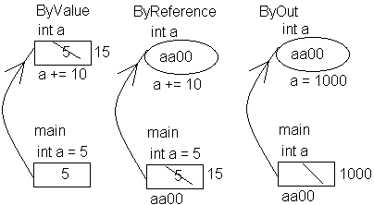
class Functions // Functions
{
static public void Fun_ByValue ( int a )
{ a += 10;
}
static public void Fun_ByReference ( ref int a )
{ a += 10;
}
static public void Fun_ByOut ( out int a )
{ // a += 10; Error: Use of unassigned local variable
a = 1000 ;
}
static public void PrintArr( int [ ] arr )
{ for ( int i = 0; i < arr.Length ; i ++ )
Console.Write("{0} ", arr [ i ] );
}

static public void Print_Ellipses ( params int [ ] arr )
{ for ( int i = 0 ; i < arr.Length ; i++ )
Console.Write("{0} ", arr [ i ] );
}
static public void Print_Ellipses_Objects ( params object [ ] arr )
{ for ( int i = 0 ; i < arr.Length ; i++ )
Console.Write("{0} ", arr [ i ] . ToString());
}
static public void Main()
{
int a = 5, b;
Program.Fun_ByValue(a);
Console.WriteLine( a ); // 5
Fun_ByReference ( ref a );
Console.WriteLine( a ); // 15
Fun_ByOut ( out a );
Console.WriteLine( a ); // 1000

// Fun_ByValue ( b ); Error: Use of unassigned local variable
// Fun_ByReference ( ref b ); Error: Use of unassigned local variable
Fun_ByOut ( out b );
Console.WriteLine( b ); // 1000

int[] arr1 = {0, 10, 20, 30, 40};
PrintArr(arr1); Console.WriteLine(); // 0 10 20 30 40

Print_Ellipses (100, 200, 300, 400); Console.WriteLine(); // 100 200 300 400
Print_Ellipses_Objects (1, 22.2222, "abcdef"); // 1 22.2222 abcdef

Console.ReadLine();
} }

